DETAILED LIST OF CHANGES ON 13/08/2026
- BillionTests→ BillionTests.AI™.
- BT Card → BTCARDX™
- At place of Kidney decease only → Kidney disease, Kidney stones, Diabetes, Dehydration and Urinary tract infections (UTIs), Liver or Bile duct problems
- → Add separate page for news & articles
  - Add 2 news shared
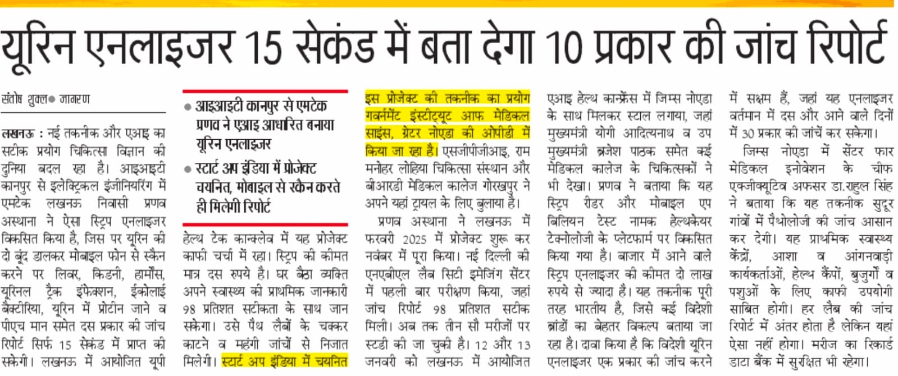
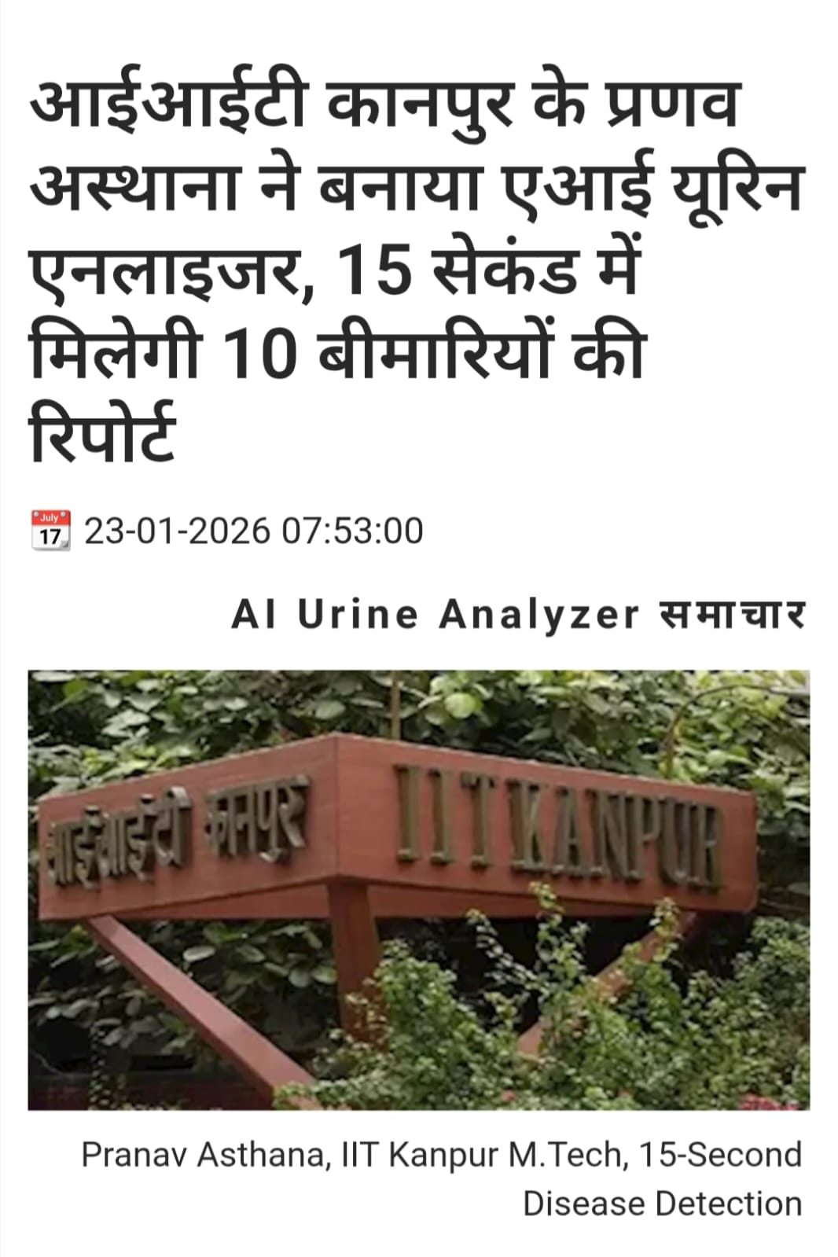

- Replace Sahil name and Pic with → Priyadarshani
- In Address → Ahmedabad, Bhubaneshwar, Bombay, Lucknow, Mohali, Washington DC
- Mention following Founders:
  - Maninder Pal Singh Sethi — Co-founder & CBO
  - Alok Kulshrestha — Co-founder & COO
  - Abhishek Chaturvedi — Co-founder & CPO
  - Priyanka Priyadarshini — Co-founder & CGO
Sr. No. | Name | Designation | Introduction | Photograph
1 | Maninder Pal Singh Sethi | Co-founder & CBO | Post Graduate in Chemistry (Hons School) from Punjab University Chandigarh. Having rich experience of 44 years in Business Development of capital goods. 10 years dedicated to AI enabled and Lab Testing Solution | 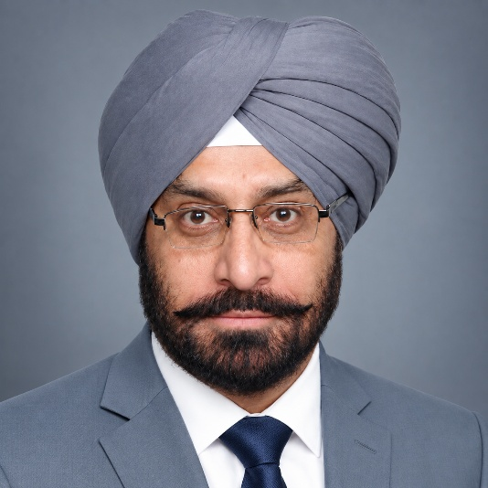
2 | Alok Kulshrestha | Co-founder & COO | Alok Kulshrestha, postgraduate from IET Lucknow. Having over five years of experience in technical sales and AI based solutions. | 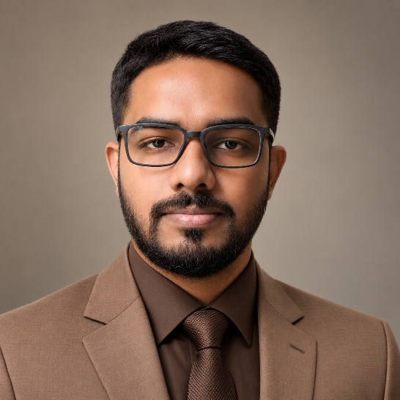
3 | Abhishek Chaturvedi | Co-founder & CPO | Postgraduate in Biochemistry and have a total of 5 years of professional experience, including the AI based product development and pharmaceutical sales | 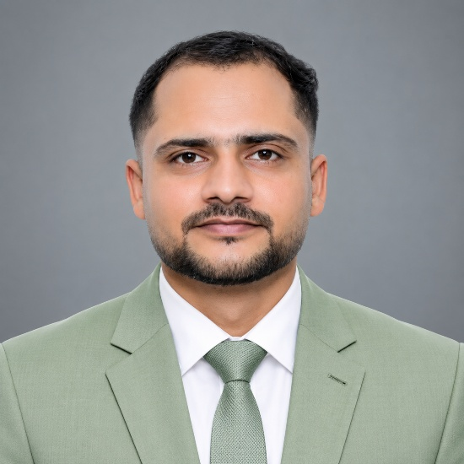
4 | Priyanka Priyadarshini | Co-founder & CGO |  | 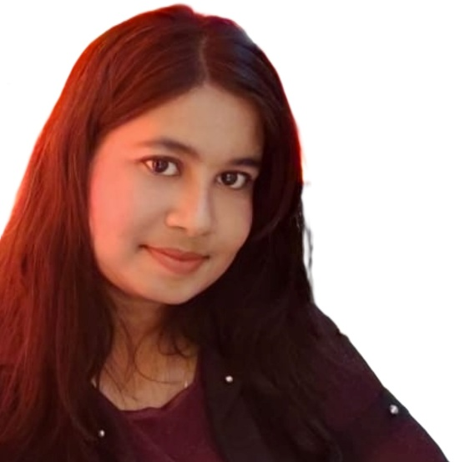

  - Pranav Asthana — Co-Inventor & Platform Head
  - Ritu Mishra — Co-Inventor & Head of Innovation
  - Pramod Prasad — RevOps Leader
- Extensible to 30+ diagnostic strips across human and animal health / human, cattle, pet → Adaptable to all standard diagnostic urine test strip variants across human health diagnostics licensed under CDSCO (Central Drugs Standard Control Organization)

- If cost Rs.10 or Rs.20 mentioned anywhere remove it → Ultra low-cost VS Rs.100-300 by any standard diagnostic labs.
- 10+ parameters→ kidney, blood sugar, UTI + 7 more parameters

- Mention accreditation from City Imaging (NABL)

- Change spellings from American → British English, e.g. “color” → “colour” and “analyzer” → “analyser.”

